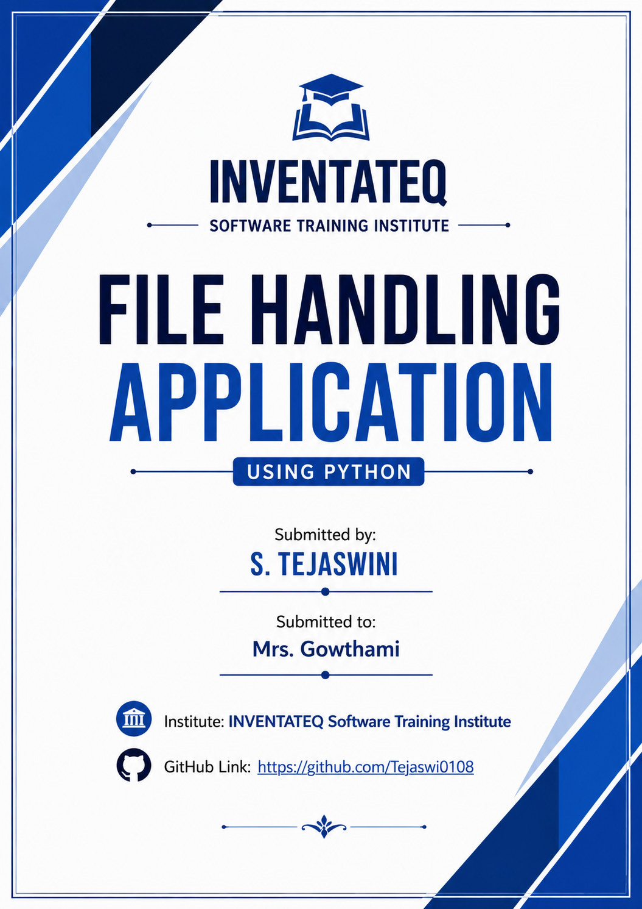

ACKNOWLEDGMENT

I would like to express my sincere gratitude to Mrs. Gowthami for her valuable guidance, support, and encouragement throughout the development of this project on "File Handling Application Using Python".
I am also thankful to INVENTATEQ Software Training Institute for providing me with the opportunity and resources to learn and complete this project successfully.
This project helped me gain practical knowledge of Python programming and file handling concepts. I would also like to thank everyone who directly or indirectly contributed to the successful completion of this project.

INDEX
S.NO | TOPIC | PAGES NO
1 | Introduction to Python
2 | Introduction to File Handling Project
3 | Concepts Used in the Project
4 | Source Code
5 | Explanation of Code
6 | Output Screenshots
7 | Conclusion
8 | Bibliography (References)

Introduction to Python
Python is a high-level, interpreted, and general-purpose programming language created by Guido van Rossum and first released in 1991. It is one of the most popular programming languages in the world because of its simplicity, readability, and versatility. Python allows developers to write programs with fewer lines of code compared to many other programming languages.
Python follows an easy-to-understand syntax that makes it suitable for beginners as well as professional developers. It supports multiple programming paradigms, including object-oriented, procedural, and functional programming. Python is widely used in web development, software development, data analysis, artificial intelligence, machine learning, automation, and scientific computing.
One of the major advantages of Python is its extensive standard library and large collection of third-party packages. These libraries help developers perform complex tasks efficiently without writing large amounts of code from scratch.
Features of Python
- Easy to learn and use
- Simple and readable syntax
- Platform independent
- Open-source and free
- Supports object-oriented programming
- Large standard library
- Dynamic typing
- Extensible and scalable
Applications of Python
- Web Development
- Data Science and Analytics
- Artificial Intelligence and Machine Learning
- Automation and Scripting
- Desktop Application Development
- Game Development
- Cybersecurity Tools
- File Handling Applications
Python has become one of the most preferred programming languages due to its flexibility, efficiency, and wide range of applications. It is an excellent choice for developing file handling applications because it provides built-in functions for creating, reading, writing, and managing files efficiently.

Introduction to File Handling
File Handling is the process of creating, reading, writing, updating, and managing files stored on a computer. In Python, file handling is an important feature that allows programs to store data permanently instead of keeping it only in memory during execution.
Files are used to save information such as text, records, logs, reports, and user data. Without file handling, all data would be lost once the program is closed. Therefore, file handling plays a vital role in developing real-world applications.
Python provides built-in functions and methods that make file operations simple and efficient. Using Python, programmers can create new files, open existing files, read data from files, write new data, append information, and close files safely.
Need for File Handling
- To store data permanently.
- To retrieve saved information whenever required.
- To manage large amounts of data efficiently.
- To maintain records and reports.
- To exchange data between different programs.
File Operations in Python
- Open a File – Used to access a file.
- Read a File – Used to retrieve data from a file.
- Write to a File – Used to store data in a file.
- Append Data – Used to add new information without deleting existing data.
- Close a File – Used to release system resources after file operations are completed.

File Modes in Python
- r – Read mode
- w – Write mode
- a – Append mode
- r+ – Read and Write mode
- x – Create a new file
Advantages of File Handling
- Provides permanent data storage.
- Helps in efficient data management.
- Easy retrieval and modification of data.
- Supports automation of data processing tasks.
- Essential for real-world software applications.
In this project, Python file handling techniques are used to create, read, update, and manage data efficiently. The project demonstrates how files can be used for storing and retrieving information in a simple and effective manner.

Concepts Used in the Project
This File Handling Application is developed using Python programming language. Several important Python concepts are used in this project to perform file operations efficiently.
1. Variables
Variables are used to store data temporarily during program execution. They help in storing user inputs, file names, and other required information.
Example:
name = "Tejaswini"
2. Functions
Functions are reusable blocks of code that perform specific tasks. Functions help in reducing code repetition and improving readability.
Example:
def add_data():
pass
3. Conditional Statements
Conditional statements are used to make decisions based on certain conditions.
Example:
if choice == 1:
print("Add Record")
4. Loops
Loops are used to execute a block of code repeatedly until a condition is met.
Types of loops:
- for loop
- while loop
Example:
while True:
print("Menu")

5. File Handling
File handling is the core concept used in this project. Python provides built-in methods to create, read, write, and update files.
Common methods:
- open()
- read()
- write()
- close()
Example:
file = open("data.txt", "w")
file.write("Hello")
file.close()

6. File Modes
Different file modes are used depending on the operation.
- r – Read
- w – Write
- a – Append
- r+ – Read and Write
These modes help in controlling file access and modification.
7. Exception Handling
Exception handling is used to prevent program crashes caused by unexpected errors.
Example:
try:
file = open("data.txt", "r")
except FileNotFoundError:
print("File not found")

8. User Input
The application accepts input from users to perform different operations.
Example:
name = input("Enter Name: ")
9. String Handling
Strings are used to store and manipulate textual data entered by users.
Example:
text = text.upper()
10. Data Storage and Retrieval
The project stores data in text files and retrieves it whenever required. This helps in maintaining records permanently.

SOURCE CODE
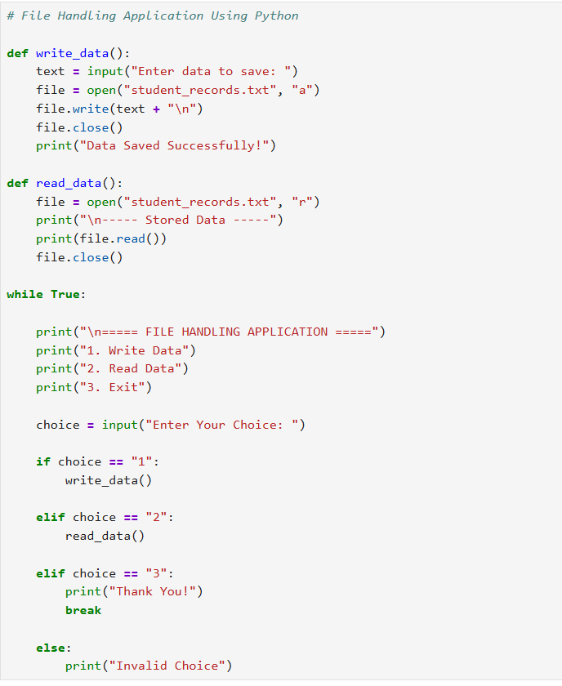

OUTPUT SCREENSHOT
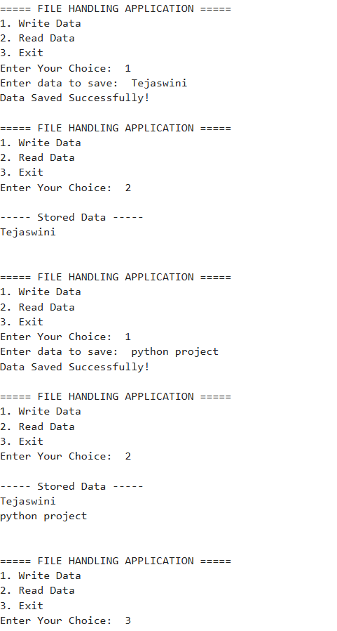

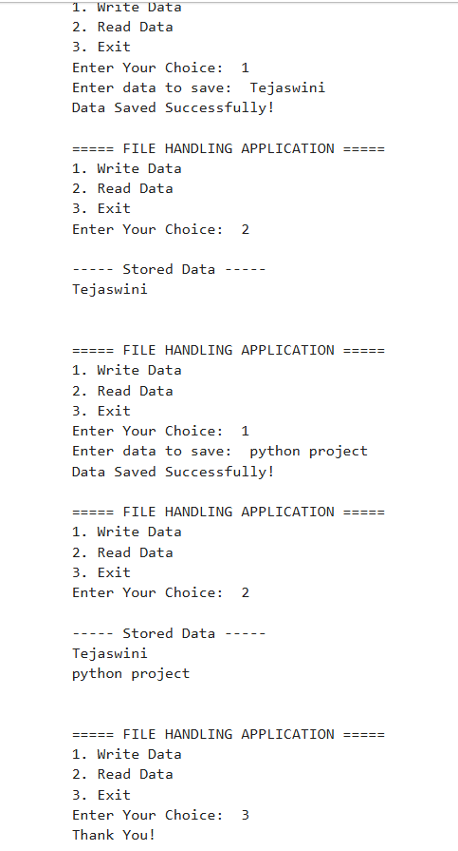

Explanation of Code

The File Handling Application is developed using Python. The main purpose of this project is to store and retrieve data from a text file using file handling operations.
1. Function Definition
The program contains two functions:
write_data()
- This function is used to save user data into a file.
- It accepts input from the user.
- The file is opened in append mode (a).
- The entered data is written into the file.
read_data()
- This function is used to read the data stored in the file.
- The file is opened in read mode (r).
- The stored content is displayed on the screen.
2. Menu Driven Program
The program uses a while loop to display a menu repeatedly.
1. Write Data
2. Read Data
3. Exit
The user can select any option according to the required operation.

3. Conditional Statements
The program uses if, elif, and else statements to perform different actions based on the user's choice.
- If the user enters 1, the write_data() function is executed.
- If the user enters 2, the read_data() function is executed.
- If the user enters 3, the program terminates.
- Any other input displays an invalid choice message.

4. File Writing Operation
The following statement is used to open the file in append mode:
file = open("student_records.txt", "a")
The entered data is stored in the file using:
file.write(text + "\n")
5. File Reading Operation
The following statement is used to open the file in read mode:
file = open("student_records.txt", "r")
The stored data is displayed using:
print(file.read())
6. Loop and Exit Operation
The while True loop keeps the application running continuously until the user selects Exit.
The break statement is used to terminate the program when the user enters option 3.

7. Concepts Used
The following Python concepts are used in this project:
- Variables
- Functions
- Input and Output Operations
- Conditional Statements
- Loops
- File Handling
- String Handling
- Break Statement

Conclusion
The File Handling Application was successfully developed using Python programming language. The main objective of this project was to understand and implement file handling concepts in a practical way. Through this project, data can be stored permanently in a text file and retrieved whenever required. This eliminates the need to enter the same information repeatedly and helps in efficient data management.
During the development of this project, various Python concepts such as variables, functions, conditional statements, loops, string handling, and file handling operations were used. The application provides options to write data into a file and read the stored data from the file. These operations demonstrate how Python can be used to manage information effectively and efficiently.
One of the major advantages of this project is its simplicity and ease of use. The user can easily store and access data without any difficulty. The project also provides a basic understanding of how real-world applications maintain and process information using files. It serves as a foundation for developing more advanced applications such as student management systems, employee record systems, inventory management systems, and database-driven applications.
Overall, this project helped in gaining practical knowledge of Python programming and file handling techniques. It improved my understanding of storing, retrieving, and managing data using files. The successful completion of this project enhanced my programming skills and provided valuable experience in developing simple yet useful applications using Python.

Bibliography (References)
- Python Official Documentation – https://www.python.org/doc/
- Python Official Website – https://www.python.org/
- W3Schools Python Tutorial – https://www.w3schools.com/python/
- GeeksforGeeks Python Programming – https://www.geeksforgeeks.org/python-programming-language/
- Python File Handling Documentation – https://docs.python.org/3/tutorial/inputoutput.html
- Course Materials and Notes Provided by INVENTATEQ Software Training Institute.
- Personal Practice and Project Development using Python Programming Language.
- GitHub Profile:
https://github.com/Tejaswi0108

